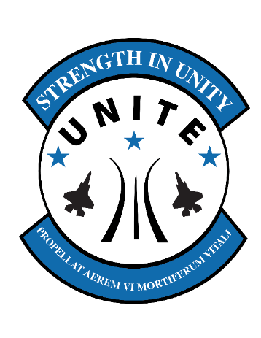

**Revitalizing**

**Squadrons**

*“…the beating heart of the Air Force.”*

Please be as specific as possible when completing the AAR.

Please turn in all DoD ID#’s to the C3 for the Rand Survey. Please remind your members that completing the survey is only 60-90 seconds. The data gathered on these surveys is very important; maximum participation is encouraged!

Please send pictures of your event to

cynthia.berg@us.af.mil

***After Action Report***

**Squadron Information**

Unit: Unit Subset:

Unit POC:

**Event Information**

Date: Time:

Number of Attendees:

Number of Anticipated Attendees:

Variance:

Reason for variance:

* Chose not to participate
* Personal conflict
* Duty-related conflict
* Other____

Were Boost Club or personal funds used to enhance event? Y/N If so, amount

*What went well?*

*Lessons learned for next time:*

*Would you host this event again? Why or Why not?*

*Do you believe that this event promoted unit cohesion? Why or Why Not?*

*POC Signature and Date*

*S*